Cricket Player Performance
Tracking Application :
CRICKSTATS

Smart Match Performance, Daily Practice Monitoring and Growth
Analysis

User Story:
As a Cricket Coach, I want to use CRICKSTATS to manage player profiles and match performances in one place and track each player’s statistics after every match. I want to check today’s player performance, compare it with previous performances, and plan tomorrow’s matches or training sessions. I also want to use team-wise player insights, automated performance summaries, player comparison, reports, and dashboards to understand player progress and make team selection and planning easier for the next match.

1.INTRODUCTION
1.1 Project Overview :
CRICKSTATS is a smart system designed for cricket coaches. Through this application, coaches can manage player profiles and match performances in a single platform. It is very useful for tracking player statistics after every match and comparing today's performance with previous performances. Similarly, tomorrow's matches and training sessions can be planned effectively. Coaches can easily understand player progress through team-wise player insights, automated performance summaries, player comparisons, reports, and dashboards. This helps make the team selection and planning process for the next match very simple.
1.2 Purpose :
- To track player match performance continuously.
- To monitor daily practice performance and activities.
- To compare yesterday’s and today’s performance.
- To identify player growth or decline.
- To calculate overall performance, recent form, and consistency.
- To display category-wise Top 5 players.
- To support Best 11 player selection.
- To remotely monitor players through the Coach Dashboard.
- To manage all player details, match records, practice data, and performance information in one file/system.
- To support player development and team planning.

2. IDEATION PHASE
2.1 Problem Statement (Customer Problem Statement Template)
Problem Statement (PS) | I am (Customer) | I’m trying to | But | Because | Which makes me feel
PS-1 | A cricket team coach | Track and manage player performance across matches and daily practice | I cannot easily compare and monitor all player performance | Player, match, and practice data are maintained separately | Frustrated and concerned about player development
PS-2 | A team manager | Maintain complete player records in one file | It takes too much time to update and manage all details | Player, match, and practice records are stored in different files | Stressed and inefficient
PS-3 | A sports analyst | Analyze player trends and generate performance reports | I face difficulty comparing yesterday’s and today’s performance | There is no centralized performance analysis system | Confused and dissatisfied
PS-4 |  | Select the best-performing players for the team | It is difficult to compare players across different categories | Performance data is not systematically analyzed | Uncertain about Best 11 selection
  A team manager

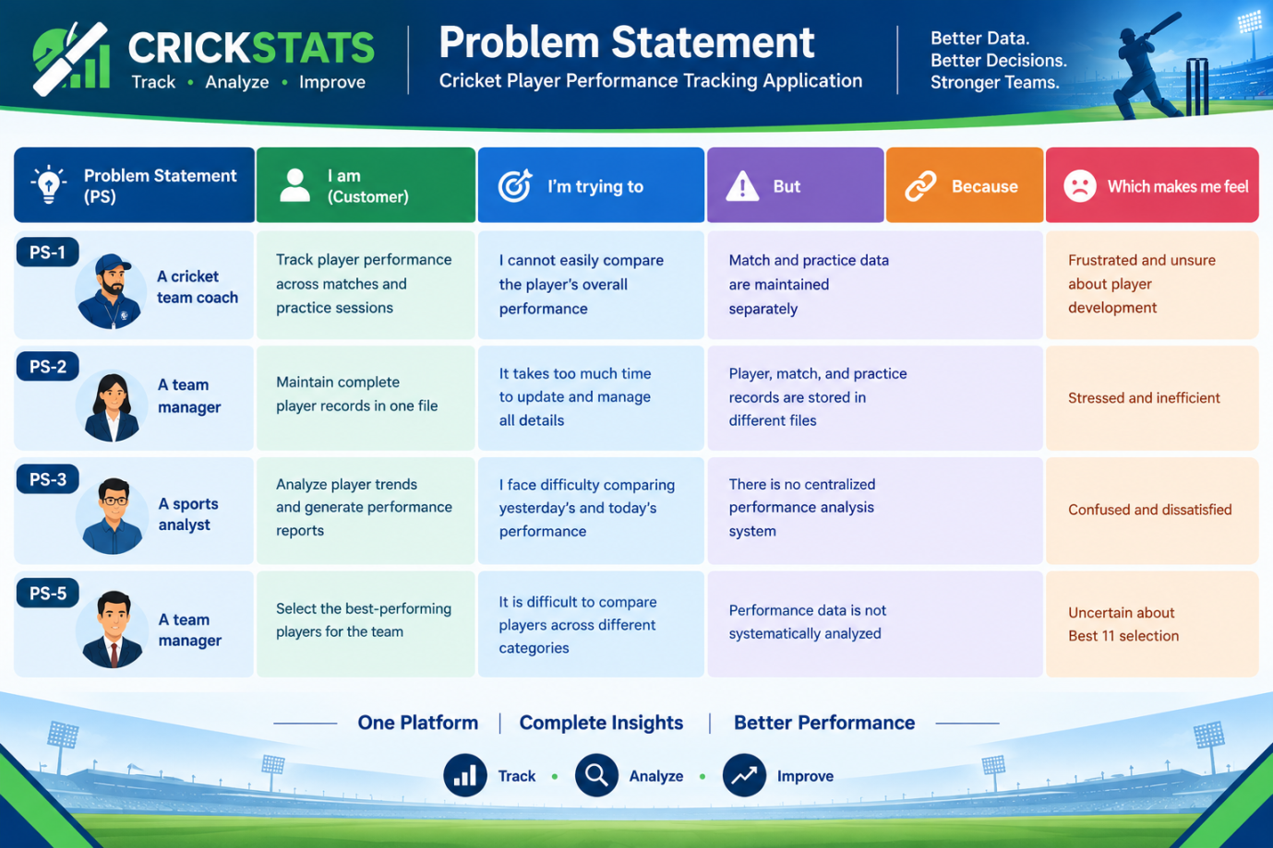

2.2 Empathy Map Canvas

Target Users
- Cricket Team Coach
- Team Manager
- Sports Analyst
- Cricket Player

Empathy Analysis

Aspect | Description
Says | Wants to manage player profiles and match performances in one place and easily check today’s performance, player comparisons, and automated summaries to plan the next match.
 | Needs reliable player statistics and team-wise insights after every match to make smarter team selections and training plans.
  Thinks
Feels | Eager to support player progress, nut overwhelmed by the challenge of handling scattered statistics, reporting, and planning manually.
Uses | Manages player profiles, tracks match statistics, checks dashboards, compares player data, and plans training sessions or matches.
Pains | Difficulty keeping track of individual statistics across matches, comparing data manually, and spending too much time trying to organize player progress for team selection.
Gains | A centralized platform (CRICKSTARS) with automated performance summaries, dashboards, player comparisons, and clear insights for seamless team planning and selection.

2.3 Brainstorming
Brainstormed Ideas
- Centralized Player Profile Manager
- Automated Performance Summaries
- Match-by-Match Performance Tracking
- Training Session Planner

Selected Idea: Cricket Player Performance Tracking Application

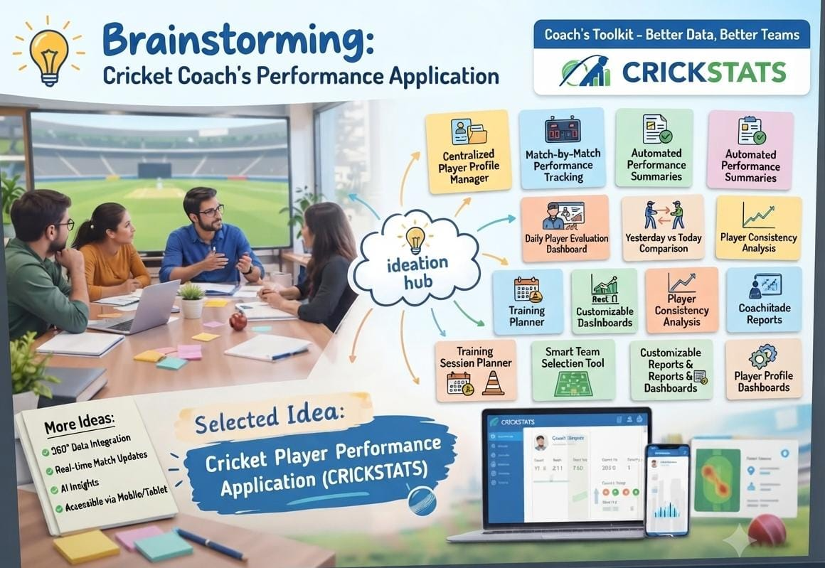

3.REQUIREMENT ANALYSIS PHASE

3.1 Customer Journey Map
Journey Stages:
- System Onboarding & Setup
- Player Profile Management
- Pre-Match Squad Review & Intelligence
- Player Comparison & Evaluation
- Team Selection & Final Strategy
- Live Match & Post-Match Data Logging
- Today’s Performance vs. Previous Trends Analysis
- Automated Report Generation
- Training Session & Practice Planning
- Continuous Progress Tracking & Future Strategy



